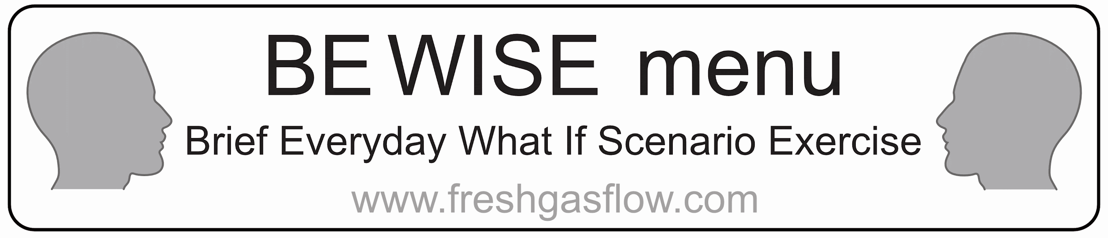

Note: This is only a sample menu. Edit to make it suitable for your hospital

* Acute Coronary Syndromes
* Adult Basic Life support
* Adult Advanced life support: VF/VT
* Adult Advanced life support: Asystole /PEA
* Anaphylaxis
* Atrial fibrillation needing urgent treatment
* Brady arrhythmias
  + include how to do emergency pacing
* Bronchospasm
* Difficult airway
  + include difficult airway trolley location & how to do front-of-neck access
* Embolism (air/clot)
* Fire drill
* Gas supply failure
* Laryngospasm
* Laser airway fire
* Local anaesthetic toxicity
* Major haemorrhage (general, obstetric)
* Malignant hyperthermia
  + Where is the dantrolene kept
* Power failure
* Supra ventricular tachycardia (narrow complex tachycardia)
* Tension Pneumothorax
* Total spinal